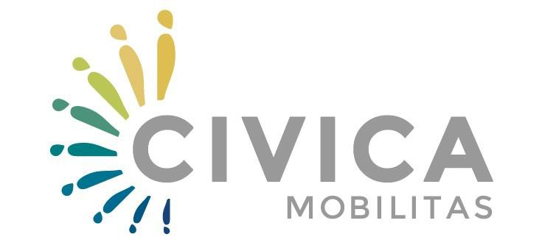

Mentoring for Organizational Development – MOD Program

CALL FOR APPLICANTS

Deadline: 17 May 2019

APPLICATION FORM

Applicant: | [Name and Surname]
Employee (s): | [Name of the Organization (if applicable)]
Application No:
(to be filled by Civica Mobilitas staff)

PART 1. THE APPLICANT

1.1. Profile of the applicant
- Personal information
Please do not forget to enclose as annex the CV of the Applicant in Experts format and Letter of Consent from the organization

Name(s) and Surname(s)
Country, Place, Date of Birth | [country, place, dd.mm.yyyy]
Gender | Female | Male |  |  |  | Other
Membership in CSOs | Yes | Which CSOs: |  |  |  | No
- Resume
[Please use this box to summarize your educational background, work experience and other information relevant to the call. You may also describe other information that for some reason are not included in your CV].
[Max. 200 words, with Segoe UI 10]
- Contact data of the Applicant
Correspondence address | [Street name and number; postal code and city/town/village, country name]
Home address if different | [Street name and number; postal code and city/town/village, country name]
Phone number (home) | [country code, area code and local number, e.g. +389 xx/xxx-xxx]
Phone number (mobile) | [e.g.+389 xx/xxx-xxx]
E-mail address (es) | [example@example.org; example@example.com]
Skype | [example]
BlogSpot | [add link] |  |  | Twitter | [add link]
Facebook | [add link] |  |  | LinkedIn | [add link]
- Specific knowledge and experience
I. Facilitation of Participatory Strategic Planning Processes |  |  | Yes |  |  |  | No
If yes, please describe shortly the beneficiaries and main activities |  |  | [max. 100 words]
II. Collaborative Consulting for Organizational Development |  |  | Yes |  |  |  | No
If yes, please describe shortly main activities and beneficiaries |  |  | [max. 100 words]
III. Interactive Training |  |  | Yes |  |  |  | No
If yes, please describe shortly in what topics |  |  | [max. 100 words]

- Motivation
What motivates you to participate in the MOD programme?
What do you hope to achieve by participating in it at your personal level, organisational level (mentees) and societal level?
[Max. 200 words, with Segoe UI 10]

1.2. Profile of the organization
[Please consider that regardless the employment status (for example full-time employee, part-time employee, unemployed, other), the field bellow is mandatory. If the applicant is a full-time employee of some organization, we expect that the applicant describes his/her current organization. In case the applicant is not a full-time employee (for example self-employed, freelancer, other), we expect that the applicant describes a previous organization where he/she has worked in the past.]
- Details of the organization
Name of the organization | as registered
Address | Street name and number; postal code and city/town/village, country name]
Website | [add link]
E-mail | [example@example.org; example@example.com]
Date of establishment
Area of work
Relation to the organization | Currently working with | I worked there in the past | Other  ………..
- Description of the organization
Conceptual frame
The Organization Development Life Cycle Theory considers that organizations are living organisms and so, evolve in time through different stages like all life forms (birth, childhood, adolescence, maturity, stagnation and renewal or decline and death) exhibiting certain specific common traits in each of the stages.

- Stage 1 - Birth: This stage is the incubation or vision stage, the organization is an idea in the minds of one or more visionary founders, not yet formalized. Imagination and inspiration abound. The primary question at this stage is “Can our dream come true?” organizational characteristics include: visionary, entrepreneurial founder(s); perceived need for an activity, a program or a service; volunteer driven/no paid staff; no formal structure.
- Stage 2 - Childhood: This stage is the organization start-up phase, when it receives its official non-profit status and all the activities of framing an organization occur. The key question is “How do we get started?” Organizational characteristics include: single minded founder(s) whose vision drives the organization; few programs; no or few staff, systems and structures; limited financial resources; small, homogenous board, lots of enthusiasm, hectic and hard work.
- Stage 3 - Adolescence: In this stage, the organization is concerned with growing the “business”, building its foundation and developing its activities.” The key question is “How can we build this to be viable?” Organizational characteristics include: Director improves and focuses on his/her managerial role; programs become more distinct, credible and begin to establish themselves in the market; staff number grows and become more specialized; revenues diversify; Board expands and formalizes, management team focuses more on planning and oversight.
- Stage 4 - Maturity: In this stage, the organization is mature, the production is at its peak and sustaining the organization is a high priority. The primary concern is “How to become sustainable?” organizational characteristics include: Director become a professional manager although there may be “Founder’s Syndrome”; programs are established and well-regarded; operations and systems are formalized; structure becomes hierarchical; there are diverse and stable revenues; board focuses more on fundraising, policy-making and planning.
- Stage 5 - Stagnation and Renewal: In this stage, the organization is reinventing itself in some way, shape or form, through a process of review and renewal. The primary question is “What do we need to redesign?” organizational characteristics include: changes in leadership; founder likely to leave; organization is out of touch with market and target clients; insufficient cash reserves; loss of financial support; programs developed primarily to attract funding; staff fragments into fiefdoms; low staff morale and high staff turnover; systems become red-tape; high board turnover; sluggish and less involved board; complacent and in denial about stagnancy OR undertake strategic planning to review and evaluate the organization and programs and develop a plan to renew the organization. A new birth through renewal and transformation can happen, OR organization can enter into stage 6
- Stage 6: Decline and death: In this stage, there is typically conflict between Director and board, staff; departure of key staff; not meeting market needs; loss of credibility with funders and clients; very low board attendance; key board members leave; high percentage of funds from only a few sources; possible bankruptcy and shut down.

Short description of my organization’s evolution in time
[While using the above model to describe your organization evolution, since its establishment till today, it is important to keep in mind that this frame shows the typical path of an organization’s journey in time and that all organizations go through each stage and their development, being an organic and nonlinear process, may include forward or backward leaps at any point or other characteristics]
[Max. 800 words, with Segoe UI 10]
Permission from the mentioned organization to elaborate their evolution in time |  | Yes | No
Contact person from the mentioned organization |  | [name and surname; position; contact e-mail; phone number]

PART 2. DeCLARATION BY THE APPLICANT

The Applicant, in the context of the present Call for Applicants, Ref. No. hereby declares that s/he:
- Has read and understood the Guidelines for Applicants and instructions set there;
- Has understood that s/he is eligible in accordance with the criteria set out under Section 3 of the Guidelines for Applicants;
- Has understood that if the organization s/he is working for will receive an Institutional Grant, s/he will not eligible to be contracted as Civica Mobilitas Mentor, after finalizing the Skills Building and Knowledge Building stages
- Will commit the necessary time and effort to attend and actively participate in the Skills Building and Knowledge Building stages, if selected to participate in the MOD Capacity Building Program.
- Has completed the Application Form as required;
- Has provided correct and complete data and information which, if required, can be proved.

Applicant | [Name and Surname]
Signature
Place and Date

PART 3. ANNEXES

Please provide following documents as annexes to the Application form:

Annex 1. CURRICULUM VITAE (EU Experts FORMAT) - Mandatory
Annex 2. Signed Letter of Consent from the organization – Mandatory only if the applicant is a full-time employee in an organization; Optional if the applicant is a part-time employee in an organization;

